**Get ready to set sail!**

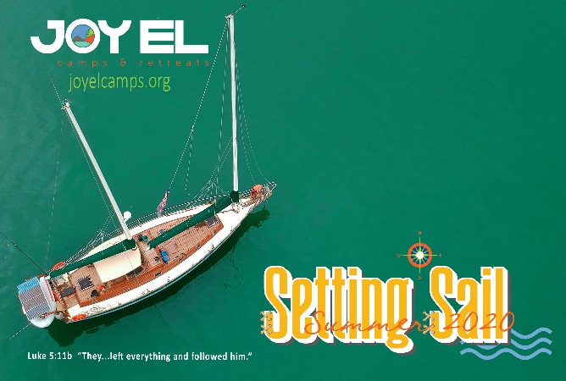

**Would you like to do Express Check-In for your camper and SAIL through the line?**

***Here is what you need by noon the Thursday before your sailor’s week of camp to be “Express”:***

Registration balance paid in full ([Complete here](https://joyelcamps.org/)).

Camper Medical Form completed ([Complete here](https://joyelcamps.org/camper-health-form/)).

Credit in Camp Store/Canteen account ([Complete here](https://joyelcamps.org/)).

Updated Waiver (<https://joyelcamps.org/parent-consent-release-statement/>)    Everyone must re-complete

**The registration process will be different this year. Prior to your child attending camp please check your email for your time for registration.**

**Here are some other great things you can add in advance for your convenience:**

Beach Berth group photo size 8x10:  $6

Opportunity to share the hope of Christ through Missions Offerings:  $5, $10, $15, $20, or more

Pick a second week of sailing fun and worship for a discount:  Call 717-369-4539 or [click here](https://joyelcamps.org/).

**OTHER SAILING INFORMATION:**

**DIRECTIONS:** For directions to 3741 Joy El Drive Greencastle, PA 17225, please [click here](https://www.google.com/maps/place/Joy+El+Camps+and+Retreats/@39.8748233,-77.7835935,16.25z/data=!4m5!3m4!1s0x0:0x9bd5b8536e4a13bf!8m2!3d39.8752105!4d-77.7834287?hl=en-US).

**CAMPER E-MAIL:** You can easily send text only e-mails to your child this summer. Go to our website menu to Summer Camps and click the “Email Your Camper” link, which takes you to Bunk1.com. Enter your pre-approved code: **JEC2020**. Set up your email account with Bunk1, or if you already have an account from previous summers you will be able to use the same account. Be sure to include the camper's name and group name in the subject line.

**DRESS:** Campers should come prepared for all types of weather and activities. **Joy El** Camps & Retreats is a Christian camp, and modesty is a must! Please, no spaghetti strap shirts, halter or tube tops, or bare midriffs, and no shorts shorter than fingertip length.

**WHAT TO BRING:** Please label all items including clothing so items can be returned if lost. Clothing: Casual camp clothes, modest one-piece swimsuit, sweatshirt or jacket, extra pair of shoes. Personal items: Towel, insect repellent, sunscreen, camera, etc. Bible & notebook.

**WHAT TO LEAVE AT HOME:** We ask that you leave behind cell phones, iPads, MP3 players, hand-held games, food and candy, skateboards, and in-line skates. Any of these items brought to camp will be collected and returned at the end of the week of camp.

**Special Health and Safety concerns for summer 2020: When arriving at camp you will be asked to certify that your camper is in good health and has not demonstrated any symptoms of COVID-19 or has not been in contact with anyone demonstrating these symptoms in the last 14 days.**

**Children at camp will be placed into groups (PODS, Point of Discipleship). Campers will NOT be required to wear a mask.**

**While at camp, and on the day camp bus, campers are NOT required to wear masks, but may bring one if desired. You may read our entire Health and Safety plan** [here](https://joyelcamps.org/wp-content/uploads/2020/05/Health-Safety-Plan-for-2020-Summer-Camp-at-Joy-El-Camps-Retreats.pdf)**.**

**HEALTH CARE INFORMATION:**

**Camp Nurse**: Qualified medical personnel will be on site each week of camp. For the safety of your child, all campers with medical needs must see the nurse at registration.

**Medications**: All prescription and over-the-counter medications must be turned in at registration. **All medicines must be in their original labeled pharmacy bottle.** Vitamins and/or homeopathics must be labeled clearly with the camper's name and dosage information.

**Special Needs**: If your camper has special health, dietary, emotional or learning needs, please notify our office via letter or e-mail prior to their week of camp. Hygiene: All campers must be lice and nit free to enter camp.

**Medical Treatment**: If you live within a 50-mile radius of camp and your child needs medical attention, other than an emergency, the family will be asked to provide transportation.

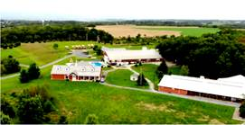

**QUESTIONS or CONCERNS?**

Please contact our office by calling (717) 369-4539 or e-mailing [info@joyel.org](mailto:info@joyel.org).

Thank you!

Anna Blazes  
Camping Ministries Assistant